**Algebra 2 Course Syllabus**

Teacher: Mike Taggart

Email: MTaggart@everettsd.org

Website: http://www.everettsd.org/jhs-MTaggart

Telephone: (425) 385-7066

**Course description**

Algebra II with Trigonometry encourages students to make sense of numbers, variables, expressions, equations, and algebraic laws in contextual situations. This course prepares students for additional study of mathematics, science, and courses rich in data analysis and statistics in high school and beyond and allows students to work with real-life data, situations, and applications. Algebra II with Trigonometry integrates algebra with geometry, statistics, data analysis, functions, probability, and trigonometry along with emphasizing inquiry, problem solving, mathematics investigation, writing, discussion, and cooperative learning.

**Course outline**

**Semester 1**

1. Sequences and Functions

2. Polynomial and Rational Functions

3. Complex Numbers and Rational Exponents

**Semester 2**

4. Exponential Functions Equations

5. Transformations of Functions and Equations

6. Trigonometric Functions

7. Statistical Inferences

**Materials Recommended**

Graph paper Composition book, graphing calculator (I recommend TI-83/84), and pencils

**Math Norms**

Everyone can learn Math to the highest levels

Mistakes are valuable

Questions are really important

Depth is much more important than speed

Math class is about learning, not performing

**Grading system**

Assessments and assignments are attached to a standard (for example, “Graphing Logarithmic Functions”). There will be no unit tests, only weekly standard based quizzes, a midterm and a final. Standard based quizzes will happen every Friday. All are assessed using a rubric scale from 0 to 4.

You earn a grade for what you know. Your job is to convince me of your understanding. Don’t like your score? *No problem!* You will reassess on any standard to show me you understand it better. You will get 2 retake quiz opportunities after that you cannot revisit a quiz.

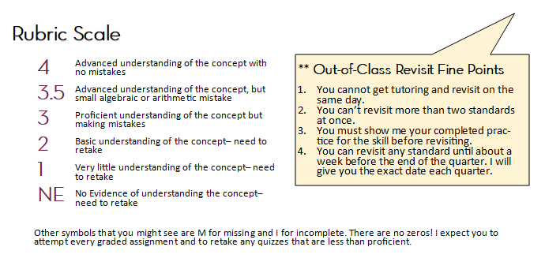

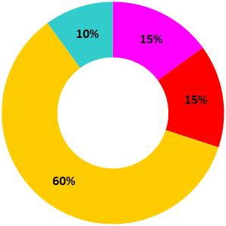

**Grading Categories**

**15% Midterm**

The midterm is taken at the end of the 1st and 3rd quarters.

**60% Quizzes**

Weekly standards quizzes can all be revisited if the student has not demonstrated Advanced understanding of the concept.

**15% Final**

The final is cumulative per semester.

**10% Homework Practice**

Practice is assigned and included in the grade. Completed practice will be required to revisit any standard outside of class.

|  |  |  |  |  |  |  |  |  |  |  |
| --- | --- | --- | --- | --- | --- | --- | --- | --- | --- | --- |
| A | A- | B+ | B | B- | C+ | C | C- | D+ | D | F |
| 3.6 – 4.0 | 3.4 – 3.59 | 3.2 – 3.39 | 2.2 – 3.19 | 2.7 – 2.89 | 2.5 – 2.69 | 2.2 – 2.49 | 2.0 – 2.19 | 1.8 – 1.99 | 1.5 – 1.79 | 0 – 1.49 |